Create a list of tuples, where the 1st element of the tuple is an int and the second
element is a string.
Example - ((1, ‘alpha’), (2, ‘beta’), (3, ‘gamma’), (4, ‘zeta’), (5, ‘omega’))
- for the above list, print the numbers where the corresponding string length is 4

scala> var tupleList = List[(Int,String)]()
tupleList: List[(Int, String)] = List()

scala> tupleList = (5, "omega") :: tupleList
tupleList: List[(Int, String)] = List((5,omega))

scala> tupleList = (4, "zeta") :: tupleList
tupleList: List[(Int, String)] = List((4,zeta), (5,omega))

scala> tupleList = (3, "gamma") :: tupleList
tupleList: List[(Int, String)] = List((3,gamma), (4,zeta), (5,omega))

scala> tupleList = (2, "beta") :: tupleList
tupleList: List[(Int, String)] = List((2,beta), (3,gamma), (4,zeta), (5,omega))

scala> tupleList = (1, "alpha") :: tupleList
tupleList: List[(Int, String)] = List((1,alpha), (2,beta), (3,gamma), (4,zeta), (5,omega))

scala> for((key,value) <- tupleList) { if(value.length == 4) println("key value is "+key+", values is "+value) }
key value is 2, values is beta
key value is 4, values is zeta

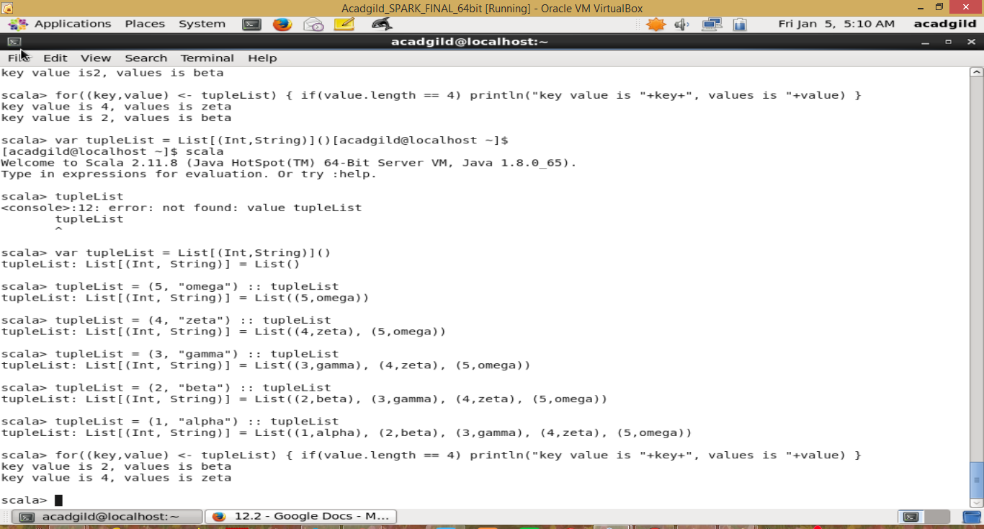

- find the average of all numbers, where the corresponding string contains alphabet ‘m’
or alphabet ‘z’

scala> var sumList = 0
sumList: Int = 0

scala> var avgList = 0
avgList: Int = 0

scala> var cntList:Int = 0
cntList: Int = 0

scala> for((key,value) <- tupleList) { if(value.indexOf('m') >= 0 || value.indexOf('z') >= 0) sumList = key + sumList }

scala> sumList
res8: Int = 12

scala> for((key,value) <- tupleList) { if(value.indexOf('m') >= 0 || value.indexOf('z') >= 0) cntList = 1 + cntList }

scala> cntList
res10: Int = 3

scala> avgList = sumList / cntList;
avgList: Int = 4

